Learning Goal
Conducting thorough research on visual aspects of the branding project.
Action
To ensure that the visual style of the branding project aligned with Woody Veneman's vision, I embarked on an extensive research process. My first step was to explore Woody’s website, analyzing his old music covers, album art, and posters. However, none of these really captured the unique vision I wanted to reflect in the new project. I also browsed his art gallery page, but again, the materials didn’t provide the strong inspiration I was looking for.
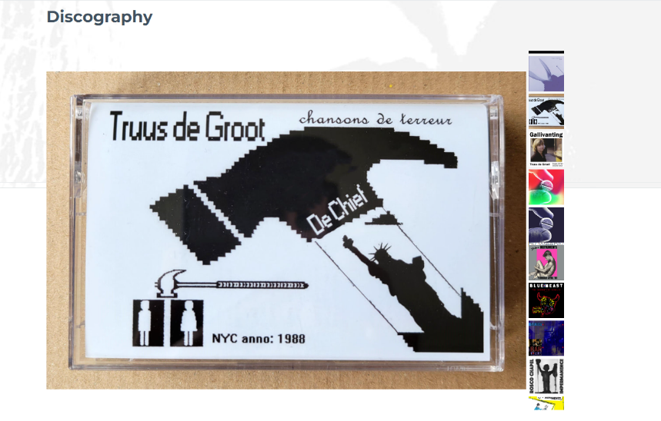
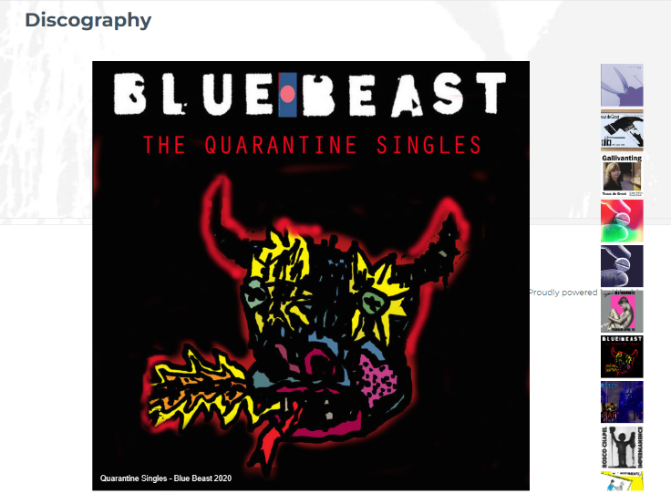
Next, I researched the work of Truus de Groot, his band partner in the Veneman en de Groot project. Her album covers and visuals were more abstract, powerfully colored, and visually striking, offering a direction that seemed more fitting. Her work, with its intense hues and energetic presentation, sparked ideas for a new aesthetic that better matched the duo’s vision.
The real breakthrough came when Woody introduced me to one of his favorite artists on Instagram, Ramusai. His work featured edgy, obscure imagery, with bold colors and elements of Goth and cybersigilism. The dramatic, eye-catching style was a perfect match for the emotional intensity of the music. This influence allowed me to incorporate similar stylistic choices into the project, bringing out the raw, energetic, and sometimes abstract qualities that aligned with both Woody’s music and his artistic preferences.
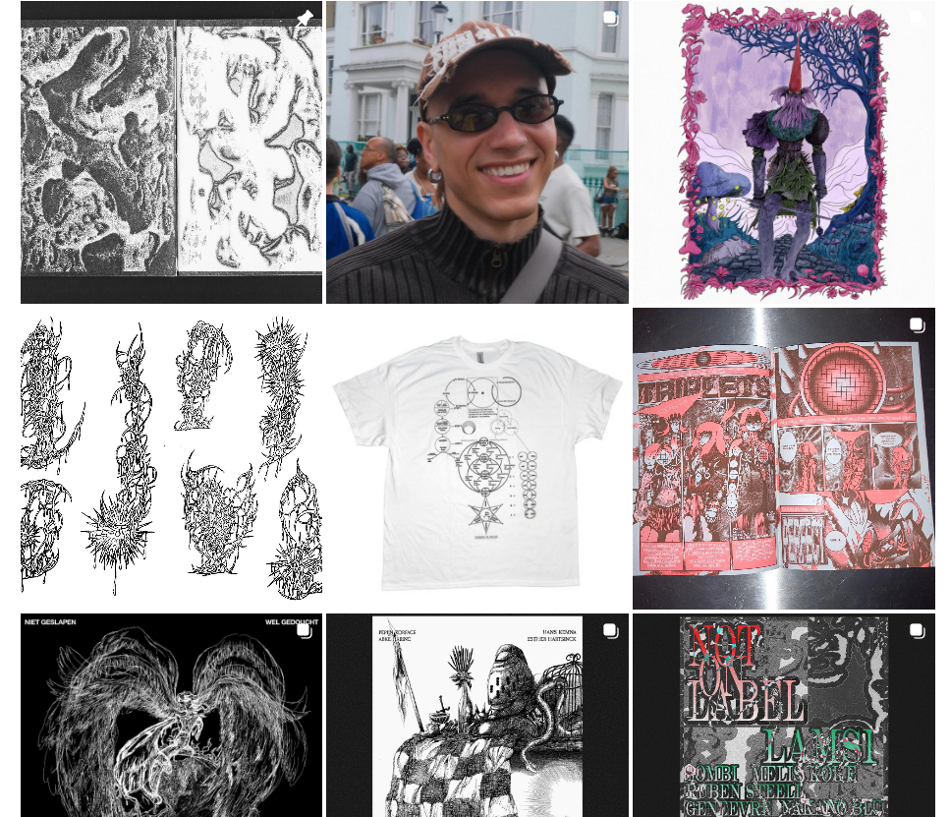
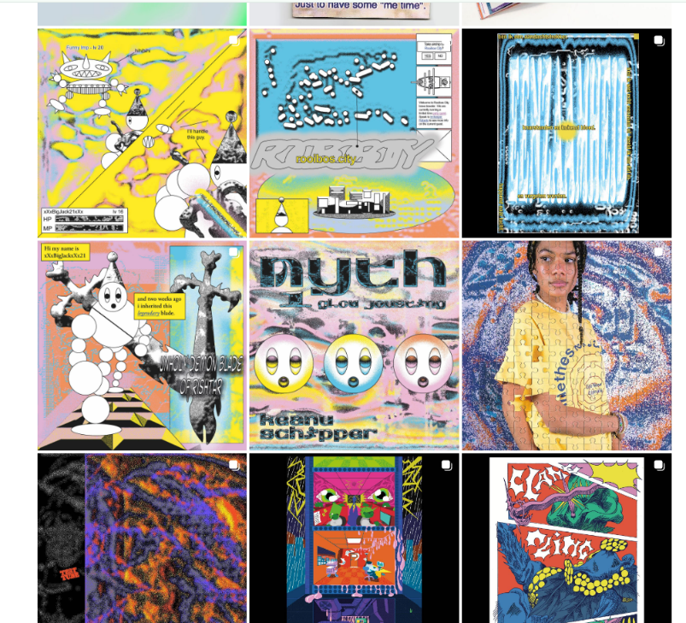
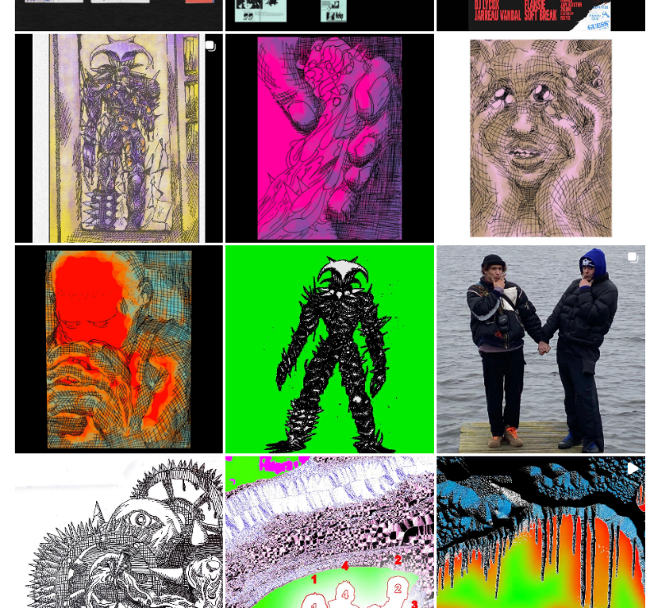
Another key part of my research process involved the lyrics. By listening to the songs repeatedly, I tried to feel the music and imagine visuals that would resonate with the themes, tones, and emotions present in the tracks. This deep dive into both the music and visual influences helped me create posters and covers that reflected the soul of the project.
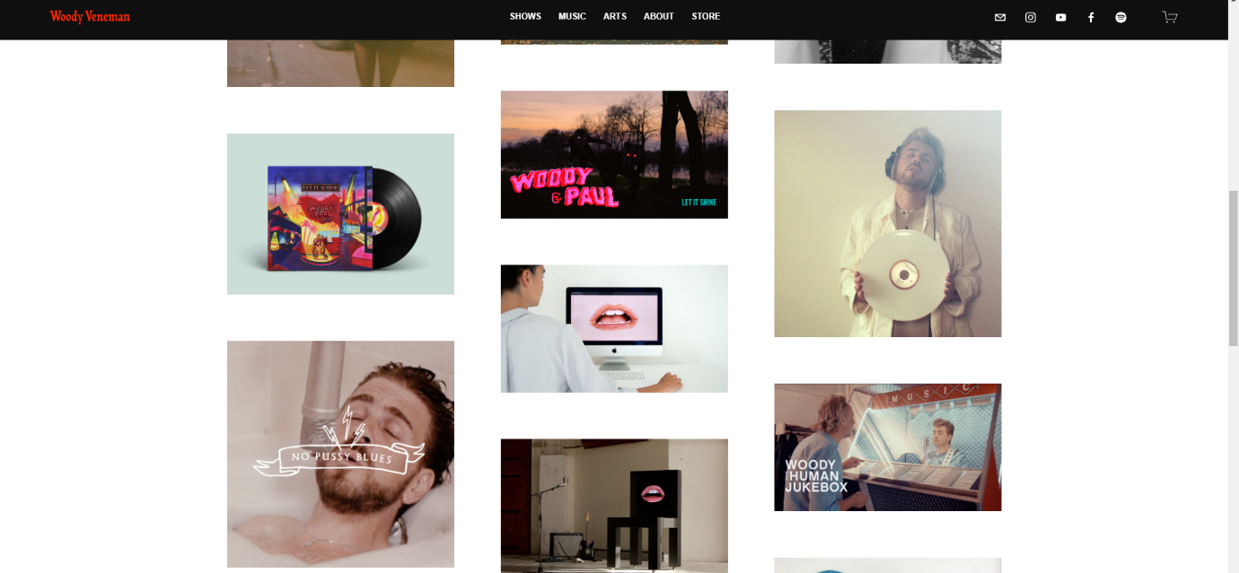
Result
The mid-project presentation marked a significant moment where the new aesthetic was revealed to Woody and the team. We moved away from the darker dive-bar-themed visuals, opting for a more vibrant color palette consisting of purples, pinks, and blues. This new abstract style was much more in line with the duo's modern "neo-smartlappen" genre and was well-received by the client. The feedback from Woody was overwhelmingly positive, and he particularly appreciated the way the visuals connected with the emotional tone of the music.
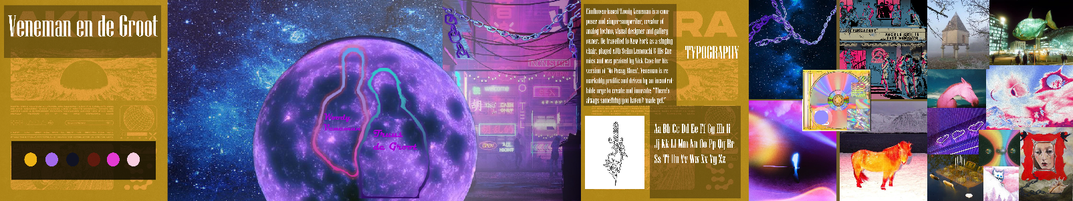
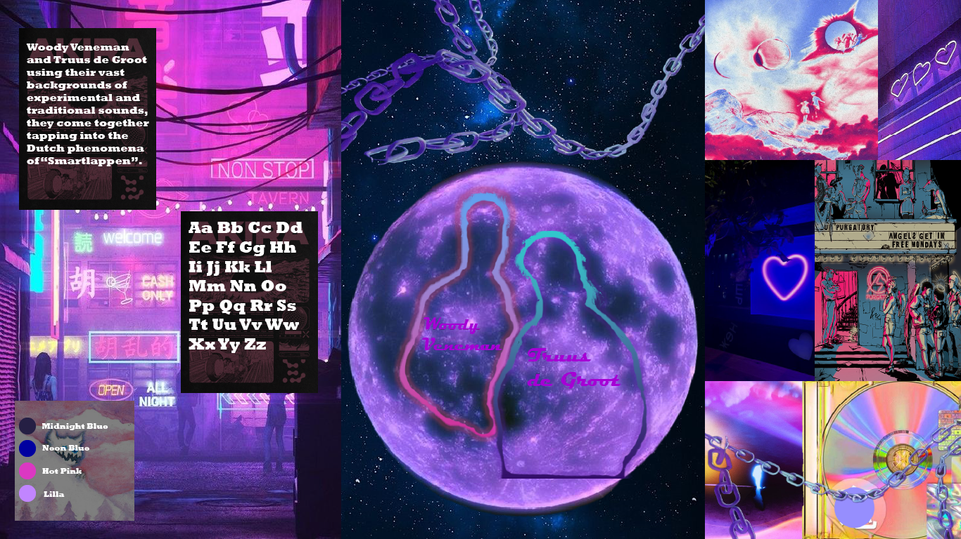
Feedback
The shift to a more abstract and colorful imagery style was not just accepted but praised. Woody highlighted how the new design truly captured the vibe he wanted to project for the duo’s modern take on Dutch smartlappen. The feedback during the mid-project review confirmed that the artistic direction was a success, as it better aligned with his vision than the original dark, bar-themed concept.
The client appreciated my research and willingness to explore various artistic avenues to reach a visual style that connected with the essence of the music. The exploration of Ramusai's art, in particular, played a crucial role in refining the final design, and Woody noted that it felt much more in tune with the energy of the music.

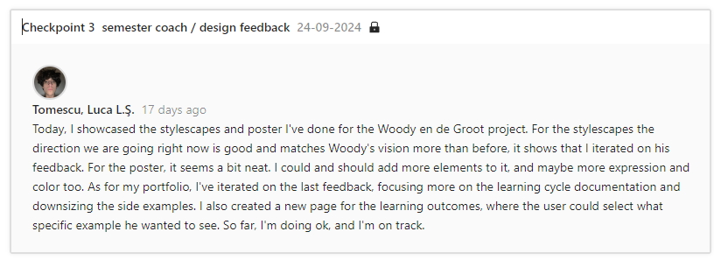
Reflection
This experience taught me a critical lesson about how important it is too deeply connected with the client’s artistic vision and to remain flexible throughout the creative process. I learned that research isn’t just about gathering visual references—it’s about truly understanding the emotion, story, and personality behind the project. This deeper connection allowed me to pivot from an initial concept that was safe and familiar to a more daring and unique design that resonated with Woody's style.
Additionally, I learned that it’s crucial not to get too attached to early ideas or concepts, as feedback or new inspiration may take the project in a completely different direction. This adaptability and willingness to explore new creative paths ultimately led to a stronger final result.

Decide
Moving forward, I plan to incorporate even more of this adaptive and research-driven approach into my future projects. I’ll make sure to stay open to feedback, even when it challenges my initial ideas, and I’ll dig deeper into understanding the essence of the project. This experience has shown me the value of thorough research and how important it is to not only understand the client’s vision but also to push myself creatively to meet and exceed those expectations. I’ll continue to apply this mindset of flexibility, research, and client alignment in all my branding and visual projects.

